VISWAJYOTHI COLLEGE OF ENGINEERING & TECHNOLOGY
CST 306 : ALGORITHM ANALYSIS AND DESIGN
Series Test 2 : March 2025
ANSWER KEY
- Write the BFS and DFS traversal of given graph. Consider M as start vertex
M
O
R
P
N
Q

Ans:
BFS Traversal: M,N,Q,R,O,P
DFS Traversal: M,N,O,P,Q,R

- Write the topological order of the graph G
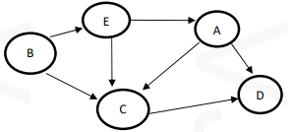
Ans: B,E,A,C,D
- Give the control abstraction of Greedy strategy
Ans:

Greedy(a, n) //a[1..n] contains n inputs
{
solution = Φ;
for i=1 to n do
{ x = Select(a);
if Feasible(solution, x) then
solution = Union(solution, x);
}
return solution;
}
- Define spanning tree of a graph. What are the properties of spanning tree
Ans:
A spanning tree is a subset of undirected connected Graph G=(V,E), which has all the vertices covered with minimum possible number of edges
  - Properties of Spanning Tree
    - A connected graph G can have more than one spanning tree.
    - All possible spanning trees of graph G, have the same number of edges and vertices.
    - The spanning tree does not have any cycle (loops)
    - Removing one edge from the spanning tree will make the graph disconnected, i.e. the spanning tree is minimally connected
    - Adding one edge to the spanning tree will create a circuit or loop, i.e. the spanning tree is maximally acyclic
    - Spanning tree has n-1 edges, where n is the number of nodes.
- Find minimum cost spanning tree of the given graph using suitable algorithm. Also find its cost.
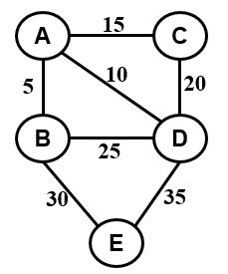
Ans:
A
D
B
E
C
5
Step 4
10
15
30
This is the minimum cost spanning tree and its cost = 60

- Compare tractable and intractable problems. Give one example to each
Ans:
    - When the complexity is expressed as some polynomial function over input size, then the concerned problem is tractable.
    - When the complexity is expressed as some exponential function over input size, then the concerned problem is intractable.
    - An intractable problem has a faster complexity growth as compared to tractable problems.
    - Tractable problem solutions are implemented in practice. They have polynomial time complexity.
    - According to Cook-Krap thesis, a problem that is in P is called tractable and that is not in P is called intractable.
    - Example of tractable problem
      - PATH problem: Given directed graph G, determine whether a directed path exists from vertex s to vertex t.
        - Time complexity = O(n)
    - Example of intractable problem
      - Knapsack Problem
        - Time Complexity = O(2^{n})

- a) A knapsack that can carry a maximum weight of 60. There are 4 items with weights {20, 30, 40, 70} and values {70, 80, 90, 200}. What is the maximum value of the items you can carry using the knapsack? Also write suitable algorithm.
Ans:

      - Arrange the objects in the descending order of profit/weight
i ={ 1, 2, 3, 4 }
P ={ 70, 80, 90, 200 }
W ={ 20, 30, 40, 70 }

Pi/Wi ={ 3.5, 2.66, 2.25, 2.85 }

Initially U=m=60
Item | Pi | Wi | Xi | U = U-Wi
1 | 70 | 20 | 1 | 40
4 | 200 | 70 | 40/70=4/7 | 0
2 | 80 | 30 | 0 | 0
3 | 90 | 40 | 0 | 0

      - Profit earned is $\sum_{i=1}^{n}{PiXi}$ = 70x1 + 200x4/7 + 80x0 + 90x0 = 184.28
      - Solution vector X={1, 0, 0, 4/7}

b) Multiply the following two matrices using Strassen’s Matrix Multiplication Algorithm.
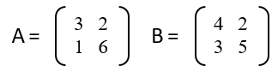
Ans:
- A and B are the matrices with dimension 2x2
- Here n is a power of 2
- Partition A and B in to 4 square matrices of size n/2 x n/2 = 1 x 1

a=3, b=2, c=1, d=6
e=4, f=2, g=3, h=5
- Compute 7 n/2 x n/2 matrices
P₁ = a ( f – h ) = 3 (2-5) = -9
P₂ = h ( a + b) = 5(3+2) = 25
P₃ = e ( c + d ) = 4(1+6) = 28
P₄ = d (g – e ) = 6(3-4) = -6
P₅ = (a + d) (e + h)= (3+6)(4+5) = 81
P₆ = (b – d)( g + h)= (2-6)(3+5) = -32
P₇ = (a – c) (e + f)= (3-1)(4+2) = 12
- Then compute
C₁ = P₄ + P₅ + P₆ – P₂ = -6+81-32-25 = 18
C₂ = P₁ + P₂ = -9+25 = 16
C₃ = P₃ + P₄ = 28-6 = 22
C₄ = P₁ – P₃ + P₅ – P₇ = -9-28+81-12 = 32
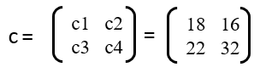
- a) Sort the data {30, 19, 35, 3, 9, 46, 10} using suitable design strategy. Also write the algorithm.
Ans:
Algorithm MergeSort(low, high)
{
mid = (low + high )/2;
MergeSort(low, mid);
MergeSort(mid+1, high);
Merge(low, mid, high);
}
Algorithm Merge(low, mid, high)
{
i= low; x= low; y= mid + 1;
while((x ≤ mid) and (y ≤ high)) do
{
if ( a[x] ≤ a[y] ) then
{
b[i] = a[x];
x = x+1;
}
else
{
b[i] = a[y];
y = y+1;
}
i=i+1;
}
if( x ≤ mid) then
{
for k=x to mid do
{
b[i] = a[k];
i =i+1;
}
}
else
{
for k=y to high do
{
b[i] = a[k];
i =i+1;
}
}
for k= low to high do
a[k] = b[k];
}
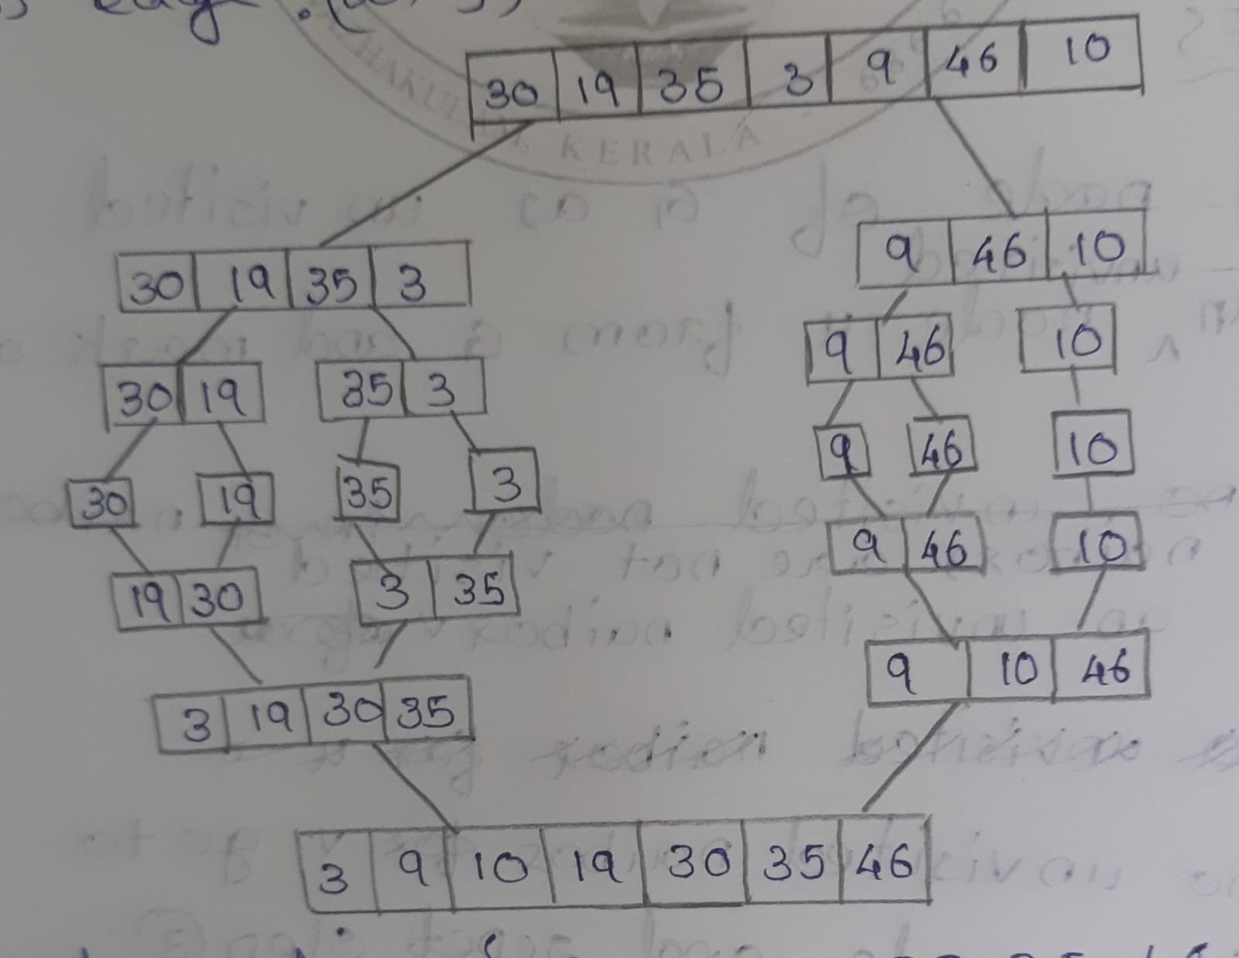

b) Apply Dijkstar’s algorithm on the given graph to find the shortest path to all destinations starting from vertex with label 1
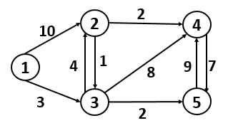
Ans:
 | 1 | 2 | 3 | 4 | 5
 | 0 | α | α | α | α
1 |  | 10 | 3 | α | α
3 |  | 7 |  | 11 | 5
5 |  | 7 |  | 11
2 |  |  |  | 9
Prev |  | 3 | 1 | 2 | 3

 | Shortest Path | Shortest Distance
1-2 | 1-3-2 | 7
1-3 | 1-3 | 3
1-4 | 1-3-2-4 | 9
1-5 | 1-3-5 | 5

- a) Prove that CLIQUE problem is NP Complete
Ans:
      - Step 1: Write a polynomial time verification algorithm to prove that the given problem is NP
        - Algorithm: Let G= (V,E), we use the set V’ ⊆ V of k vertices in the clique as a certificate of G
          - Test whether V’ is a set of k vertices in the graph G
          - Check whether for each pair (u,v) ∈ V’, the edge (u,v) belongs to E.
          - If both steps pass, then accept. Otherwise reject.
        - This algorithm will execute in polynomial time. Therefore CLIQUE problem is a NP problem.
      - Step 2: Write a polynomial time reduction algorithm from 3-CNF-SAT problem to CLIQUE problem(3-CNF-SAT ≤p CLIQUE)
Algorithm
          - Let Ф = C₁ ˄ C₂ . . . . . ˄ C_{k} be a Boolean formula in 3CNF with k clauses
          - Each clause C_{r} has exactly three distinct literals l^{r}₁, l^{r}₂, l^{r}₃.
          - Construct a graph G such that Ф is satisfiable iff G has a click of size k.
          - The graph G is constructed as follows
            - For each clause C_{r} = (l^{r}₁ V l^{r}₂ V l^{r}₃) in Ф, we place a triple of vertices V^{r}_{1,} V^{r}₂ and V^{r}₃ in to V.
            - Put an edge between V^{r}_{i} to V^{s}_{i} if following two conditions hold
              - V^{r}_{i} and V^{s}_{i} in different triples( that is r!=s)
              - l^{r}_{i} is not a negation of l^{s}_{i .}
      - Example: Ф = (x₁ V ךx₂ V ךx₃) ˄ (ךx₁ V x₂ V x₃) ˄ (x₁ V x₂ V x₃)
The graph G equivalent to Ф is as follows
x₁
ךx₂
ך x₃
x₃
x₂
x₁
x₃
x₂
ך x₁
If G has a clique of size k, then Ф has a satisfying assignment. Here k=3.
x₁
ךx₂
ך x₃
x₃
x₂
x₁
x₃
x₂
ך x₁
G can easily be constructed from Ф in polynomial time.
So CLIQUE problem is NP Hard.
      - Conclusion: CLIQUE problem is NP and NP Hard. So it is NP-Complete
b) Find strongly connected components of the digraph given below. Write the algorithm and analyse its complexity
B
A
D
F
G
C
H

Ans:
Pass 1: Perform DFS traversal and construct the stack
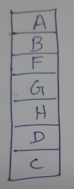
Pass 2:
Reverse the graph
SCC1: A-C-D-B
SCC2:F
SCC3:H
SCC4: G
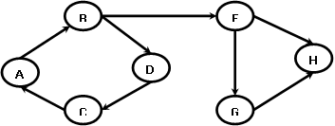

- a) Explain P, NP, NP hard and NP complete problems
Ans:
  - Class P
    - Class P consists of those problems that are solvable in polynomial time.
    - P problems can be solved in time O(n^{k}). Here n is the size of input and k is some constant.
    - Example:
      - PATH Problem: Given directed graph G, determine whether a directed path exists from s to t.
Algorithm
          - Inputs: <G,s,t> G – directed graph s,t – 2 nodes
          - Place a mark on node s and enqueue it into an empty queue.
          - Repeat step 3 until the queue is empty
          - Dequeue the front element a. Mark all unvisited neighbors of a and enqueue those into the queue.
          - If t is marked, then accept. Otherwise reject.
Complexity Calculation
          - Step 1 & 4 will execute exactly once.
          - Step 3 & 4 will execute atmost n times, where n is the number of nodes in G.
          - Time complexity = O(n).
          - This is a polynomial time algorithm.
  - Class NP
    - Some problems can be solved in exponential or factorial time. Suppose these problems have no polynomial time solution. We can verify these problems in polynomial time. These are called NP problems.
    - NP is a class of problem that having only non-polynomial time algorithm and a polynomial time verifier.
    - Example:
      - Hamiltonian path(HAMPATH) Problem
        - A Hamiltonian path in a directed graph G is a directed path that goes through each node exactly once.
        - There is no polynomial solution to find the Hamiltonian path from s to t in a given graph.
        - The HAMPATH problem is to test whether a graph contains a hamiltonian path connecting 2 specified nodes.
        - HAMPATH problem have a feature called polynomial verifiability. Here verifying the existence of a Hamiltonian path may be much easier than determining its existence.

        - HAMPATH Verifier Algorithm
          - Inputs
            - G: the graph
            - s,t: two vertices
            - P: the path P₁, P₂, . . . . P_{m} where m is the number of nodes in the graph G

          - Algorithm
            - Check whether s= P₁ and t= P_{m}. if either fails, reject
            - Check for the repetition of the nodes in the list P. If any are found, reject.
            - For each i, check whether (P_{i}, P_{i+1}) is an edge in G. Here i is varies from 1 to m-1. If any are not, reject.
            - If all test have been passed, then accept it.
          - This algorithm runs in polynomial time. Therefore HAMPATH problem is a NP problem.

    - NP- Hard
      - If a decision problem X is NP-Hard if every problem in NP is polynomial time reducible to X.
      - Y ≤p X for every Y in NP
      - It means that X is as hard as all problems in NP.
      - If X can be solved in polynomial time, then all problems in NP can also solved in polynomial time.

  - Class NP-Complete
      - If the problem is NP as well as NP-Hard, then that problem is NP Complete.
      - Example:
        - CIRCUIT-SAT problem: Given a Boolean circuit C, is there an assignment to the variables that causes the circuits to output 1

b)Write DFS algorithm and analyse its time complexity. What are classification of edges that can be encountered during DFS operation and how it is classified?
Ans:
Algorithm DFS(G, u)
        - Mark vertex u as visited
        - For each adjacent vertex v of u
  - if v is not visited
    - DFS(G, v)

Algorithm main(G,u)
        - Set all nodes are unvisited.
        - DFS(G, u)
        - For any node x which is not yet visited
  - DFS(G, x)

      - Complexity
        - If the graph is represented as an adjacency list
          - Each vertex is visited atmost once. So the time devoted is O(V)
          - Each adjacency list is scanned atmost once. So the time devoted is O(E)
          - Time complexity of DFS = O(V + E).
        - If the graph is represented as an adjacency matrix
          - There are V² entries in the adjacency matrix. Each entry is checked once.
          - Time complexity of DFS = O(V²)

      - Classification of Edges
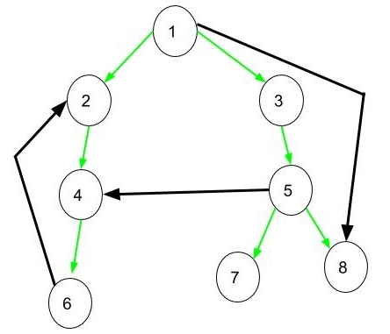
    - The DFS traversal of the above graph is 1 2 4 6 3 5 7 8
    - Tree Edge: It is a edge in tree obtained after applying DFS on the graph
      - Eg: (1,2), (2,4), (4,6), (1,3), (3,5), (5,7) and (5,8)
    - Forward Edge:
      - It is an edge (u, v) such that v is descendant but not part of the DFS tree
      - Eg: (1,8)
    - Backward Edge
      - It is an edge (u, v) such that v is ancestor of edge u but not part of DFS tree
      - Eg: (6,2)
    - Cross Edge
      - It is a edge which connects two node such that they do not have any ancestor and a descendant relationship between them.
      - Eg: (5,4)

